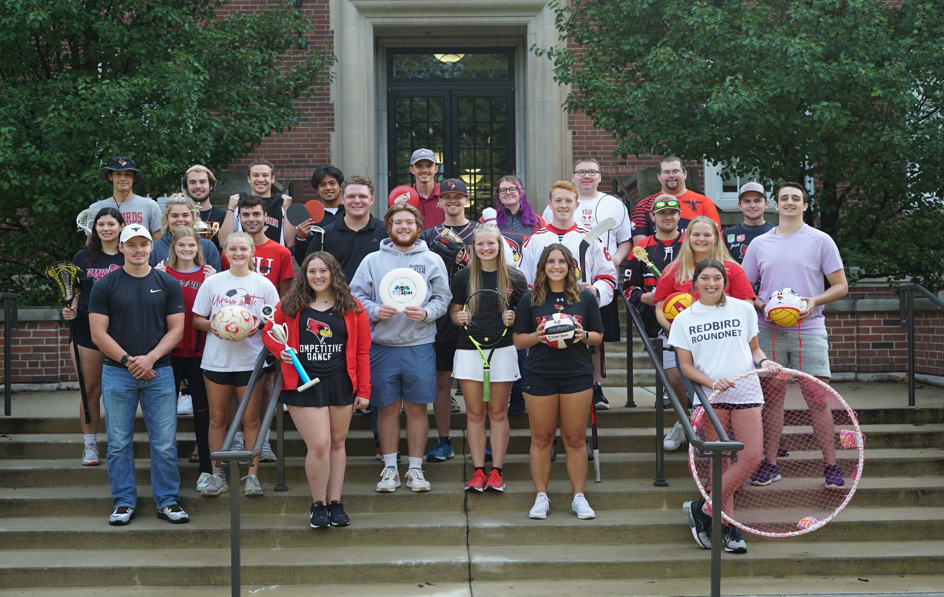

2026-2027

Table of Contents
SPORT CLUB ADMINISTRATION 5
IMPORTANT CONTACTS 5
CAMPUS RESOURCES 5
CAMPUS RECREATION MISSION STATEMENT 6
INTRODUCTION TO SPORT CLUBS 6
SPORT CLUB GENERAL INFORMATION & EXPECTATIONS 7
Compliance Program 7
Club Participation 8
Notification of Changes 8
Withdrawal of Registration 8
Constitution 9
SPORT CLUB LEADERSHIP 9
Club Officers and Duties 9
Coaches 9
Faculty/Staff/Graduate Assistant Advisors 10
Sport Club Executive Board 10
CODE OF STUDENT CONDUCT 11
Anti-Harassment and Non-Discrimination in Membership Clause 11
Hazing 11
FUNDING INFORMATION 12
General Information 12
Funding Guidelines 12
Off-Campus Bank Account 13
Student Fee/Program Allocation Fund 13
Opportunity Fund 14
Foundation Account 14
Alumni Relations 15
Tax-Exempt Status 15
Utilization of Allocation Monies and Reimbursement 15
Fiscal Management by Clubs 17
SAFETY 18
Elements of Risk Management 18
Inclement and Severe Weather 19
Safety Officers 19
First Aid Kits 19
Accidents & Incidents 20
Writing an Accident or Incident Report 20
Athletic Trainer/EMT Presence (high impact sports) 22
SMART Clinic 22
Club Activity Definitions 22
Home and Away Event Registration 24
Travel Rules 25
Class Absence Letters for Sport Club Events 25
Personal Vehicle Accidents 27
RESERVING ISU FLEET VEHICLES FOR CLUB TRAVEL 27
University Fleet Vehicle Accidents 27
FACILITY REQUESTS 28
Practice Sessions 29
General Rules 29
MISCELLANEOUS 30
Redbird Life 30
Sport Club Leadership Series 30
Team Building Activities 30
“Clubs That Care” Community Involvement 30
Involvement Form 31
Sport Club Leadership Awards 31
Info Meetings 31
Apparel and Branding 31
Recruitment Opportunities 33
Club Social Media 33

SPORT CLUB ADMINISTRATION
Kelsey Orrill
Assistant Director, Competitive Sports
309-438-2577
korrill@ilstu.edu
sportclubs@ilstu.edu
Chris Yeager
Coordinator, Competitive Sports
309-438-3705
cmyeage@ilstu.edu

Paul Amado
Graduate Assistant, Competitive Sports
309-438-3888

IMPORTANT CONTACTS
Campus Recreation (Main Office) ……………………………………………………………………………………………. Office: 438-3700
Student Fitness Center ………………………………………………………………………………………………………………………..438-7529
Student Activities and Involvement …………………………………………………………………………………………………..438-3212
Van Training (Facilities Management) ……………………………………………………………………..ISUFleetTraining@ilstu.edu

CAMPUS RESOURCES
Bone Student Center …………………………………………………………………………………………………………………………..438-4636
Campus Classroom Scheduling (other than McCormick)……………………………………………………………………… 438-2403
Environmental Health and Safety …………………………………………………………………………………………………………438-8325
Fleet Dispatcher (University Vehicles) …………………………………………………………………………………………………438-2038
Health Promotion and Wellness ………………………………………………………………………………………………………….438-9355
Newspaper – Daily Vidette ………………………………………………………………………………………………………………….438-8530
SMART Clinic ……………………………………………………………………………………………………………………………………….438-1892
Student Conduct and Community Responsibilities ……………………………………………………………………………….438-8621
Student Counseling Services ……………………………………………………………………………………………………………….438-3655
Student Health Services ………………………………………………………………………………………………………………………438-8655
University Police ………………………………………………………………………………………………………………………………….438-8631

University Registrar ……………………………………………………………………………………………………………………………..438-2188

Technology Note: If technology ever fails for any process, we will follow through with a paper option. For example, waivers, event registration, participation, accident/incident report.

CAMPUS RECREATION MISSION STATEMENT
Campus Recreation encourages the campus community to embrace fun and well-being through movement, challenge, and play.

VALUES:
Learning and Development – Promote leadership, growth, and critical thinking
Belonging – Create a welcoming, safe, and valued community
Responsibility – Ensure accountable, ethical, informed decisions
Respect - Embrace an inclusive and equitable environment
Teamwork – Cultivate a fun, collaborative, and transparent atmosphere

INTRODUCTION TO SPORT CLUBS
The purpose of the Illinois State University Sport Club program is to provide athletic opportunities to students who are seeking competition and camaraderie. ISU Sport Clubs are student-led and funded, with advisement and support provided by Sport Club Administration. The Sport Club program provides an avenue for Illinois State students to develop leadership and organizational skills, promotes teamwork, accountability, fun, service, integrity, safety, and provides an outlet for students dedicated to a sport to pursue it at a high level across the state, region, and country.
Each club is required to maintain active status as a Registered Student Organization (RSO) through the Dean of Students Office. Clubs are classified as independent organizations by the Dean of Students Office. The co-curricular environment provides an emphasis on student leadership, development, and learning as students are directly responsible for fundraising, public relations, organization, administration, budgeting, scheduling, decision making, and conflict resolution as it relates to their club. Campus Recreation will serve in a support role for supervision and coordination of all club activities.
Participation in a Sport Club is strictly voluntary. Each participant should understand that the possibility of bodily and other injury does exist and every member must sign a participation waiver to that effect before physically participating with the club. Officers are responsible for ensuring participants have signed this waiver before participation. Illinois State University does not provide accident or medical insurance for club members and cannot be held responsible for injuries during travel or participation in voluntary activities. Club participants are also held in the highest regard as it relates to personal and team conduct. Incidents, behavior deemed inappropriate, and violation of the procedures outlined in this Handbook are handled in accordance with the Sport Club Compliance Program and the Illinois State University Code of Student Conduct, when applicable.
The purpose of the Sport Club Handbook is to outline the procedures of Illinois State University and the Department of Campus Recreation for the general operation of a Sport Club. It also serves as a how-to resource guide to answer questions that arise in the course of leading the club. The procedures outlined in this Handbook are subject to change and officers will be notified of any changes via email from Sport Club Administration.

SPORT CLUB GENERAL INFORMATION & EXPECTATIONS
Clubs who choose to participate in the Sport Club Program accept the responsibilities and expectations of their Sport Club status. If a club fails to uphold these standards, they risk their active status within the program. These standards include, but are not limited to:
- Be controlled and directed by ISU students. Mirroring the guidelines laid out for Registered Student Organizations, a minimum of five currently enrolled (at least one credit hour) ISU students are required to be a sport club
- Maintain a President, Treasurer, and two safety officers at all times (clubs are allowed to add additional officers as they see fit per their constitutions). Officers on file with Campus Recreation must be currently enrolled, fee-paying ISU students and meet all National Governing Body (NGB) eligibility standards
- Abide by all regulations specified by Dean of Students Office for independent organizations, this Handbook, the Illinois State University Code of Student Conduct, and the Sport Club Compliance Program
- Maintain active status on Redbird Life, which includes maintaining an accurate roster, contact information, constitution, and submitting participation each month be the established deadline
- Be advised by a full-time faculty, staff member, or graduate assistant at ISU that is not associated with Campus Recreation. The advisor should be able to consult and provide support to the Sport Club, when requested by the club
- Demonstrate ability to handle club finances in an appropriate manner, including responsible use of an off-campus club bank account and paying all debts in timely manner
- Active affiliation with a National Governing Body (NGB) for the respective sport, if applicable
- Compete at least three times throughout the year and/or work towards a national event
- Complete all Sport Club Program paperwork by established deadlines
- Attend all scheduled trainings and meetings as called by Sport Club Administration
- Regularly communicate with Sport Club Administration, including updating information, responding to emails, and asking questions
- Develop and work towards accomplishing annual goals and objectives for recruitment, fundraising, and competition
- Fully participate in the safety directives of the Sport Club Program
- Confirm that all sport club members are eligible and have signed the waiver before participating

Compliance Program
The Sport Club Compliance Program was created in order to supplement incidences and violations not highlighted in the Illinois State University Code of Student Conduct that are of particular significance to the club program. The document encourages accountability for both individual participants and club teams as it relates to club compliance with Handbook, paperwork, meetings, sportsmanship, safety, conduct, and behavior. Clubs should also note that their coaches and spectators should reflect these values as they are an extension of the club and can negatively impact their reputation. Clubs and members will be held accountable through the Compliance Program, and it is the responsibility of club officers to familiarize themselves with these materials.

Note: Clubs that have been removed from the Sport Club program due to compliance violations are not eligible to re-register for Sport Club status until all sanctions and restrictions outlines in their compliance letter have been completed and they have been an active RSO for one full academic year. These groups would then need to apply as a NEW Sport Club and be subject to those guidelines, if re-approved by the Executive Board.

Club Participation
Each Sport Club participant must complete and submit a Sport Club Waiver (follow link for access, log in using central log-in) before physical participation with a club and be a currently enrolled, fee-paying ISU student. Faculty/staff (whose primary appointment is F/S - including those enrolled in classes with a tuition-fee waiver) and non-ISU individuals are not permitted to participate. Once they have submitted this waiver correctly, they do not have to resubmit for the remainder of their tenure at ISU. If an individual only attends an interest meeting and does not engage in physical club activity beyond the meeting, no waiver is required.

If officers need confirmation of which members have submitted a waiver, they may request a list of names from Sport Club Administration via email, but the list will not have any student information other than first and last name.

Clubs can expect random roster checks throughout the year where members will be asked to produce their Redbird ID and verify a waiver is on file. The Competitive Sports Student Team Member on duty has the right to stop individuals from practicing/competition if they are unable to produce their Redbird ID. There will also be cross checks between our waiver database and Redbird Life Rosters, so officers should ensure those are updated as people join/leave the club.

Notification of Changes
All club names should read “Club Name at Illinois State University” whenever possible as clubs are classified as independent organizations. When an organization changes its name, revises its constitution, selects new officers, choses a new advisor, and/or when telephone numbers of officers change during the academic year, such changes must be reported to Sport Club Administration and reflected on Redbird Life. Failure to notify of changes could result in sanction.

Withdrawal of Registration
Any organization may withdraw its registration and disband as a club at any time by notifying Sport Club Administration. Disposition of organizational funds, if any, and confirmation that there are no outstanding debts, must accompany the withdrawal. Upon the date of notification of the withdrawal of registration, the organization forfeits all privileges afforded to Registered Student Organizations (RSOs) and Sport Clubs. It is possible for a club to terminate their association with the Sport Club program and remain an active RSO (pending there are no discipline concerns), but they would forfeit all sport club benefits. It is recommended that the club’s constitution address what happens to club equipment and funds in the event they disband (for example, off-campus bank account funds will be deposited to the club’s University Foundation account).

Constitution
A constitution is the basic framework of an organization. It is used to provide an administrative structure for the club. Everything the club does, or could do, should be considered when drafting this document. If anything happens with the club, the constitution will be referenced to see how your group outlines management of that situation. Club Officers can reference their Microsoft Teams folder to see a sample constitution that includes items clubs must include and other suggestions for content.

Clubs are required to submit an updated constitution at the start of each fall semester to Sport Club Administration for review and the deadline for submission will be communicated via the Fall Schedule of Events. Clubs should maintain the most updated version of their constitution on Redbird Life. An updated constitution will also be required for re-registration as a Registered Student Organization.

SPORT CLUB LEADERSHIP
Sport Clubs are dynamic, active student organizations. Each club is unique, possessing their own challenges and successes. The leadership of your club rests in the hands of the student officers. Coaches, instructors, and advisors are important figures within the makeup of the club and in the execution of the club mission and goals. However, at no time should a coach, instructor, or advisor be in a position to dictate to club members or officers how the club must be administered. Clubs that experience this situation can contact Sport Club Administration for assistance in addressing the situation.

In the end, a successful club finds an administrative structure that supports the many functions necessary for club success. Often, this is accomplished through finding a functional balance between club officers, coaches/instructors, the club’s advisor, and Sport Club Administration.

Club Officers and Duties
All Sport Clubs are required to maintain an active President, Treasurer, and two safety officers throughout the entirety of the academic year and can create as many supplemental positions as they wish, such as Vice President, Fundraising Chair, or Social Media Manager. Sport Clubs are strongly encouraged to elect and/or appoint their club officers early in the spring semester (around January or February) to give the club’s new leaders the necessary time to transition into their new positions. By concluding the election/appointment process early, it will allow new leadership the opportunity to shadow, ask questions, and prove their capabilities prior to officially taking office. Please see the sample constitution for a detailed list of main officer responsibilities and other common officer positions/responsibilities.

Coaches
Clubs may solicit the services of coaches to assist with the teaching/coaching aspects related to their sport. Coaches do not need to be affiliated with Illinois State University. The club cannot use their University allocation funds to pay coaches. Coaches should, to the extent possible, restrict their involvement in the club to teaching and coaching. Sport Clubs are student organizations and administratively must be handled through the club members and officers. The emphasis is on student leadership and development. Clubs should address coaches, including hiring, payment, removal, role, and expectations in their constitution. If coaches are added/removed, officers should notify Sport Club Administration as contact information is tracked.

The coach should:
- Coach the players to the best of their ability
- Encourage club members to adhere to the Code of Student Conduct, Sport Club Handbook & Compliance Program, and the safety guidelines provided by Sport Club Administration
- Promote good sportsmanship at all times
- Be current with all certifications required of their coaching position

Faculty/Staff/Graduate Assistant Advisors
As a Registered Student Organization, every Sport Club is required to have a full time ISU faculty, staff member, or GA serving as an advisor. This person cannot be associated with Campus Recreation. The key role of the advisor is to serve as another resource for the organization. It is important to spend time establishing expectations of both parties to develop the best collaborative and supportive relationship.

An advisor can use personal expertise and perspective to stimulate individual development of members and the overall development of the organization. Clubs will also utilize their advisor to maintain ‘active’ status and to sign facility requests, if they are attempting to reserve a campus facility. If a club changes their advisor, Sport Club Administration should be notified immediately and the change reflected on the club’s Redbird Life roster. If a club is having difficulty identifying an individual to serve as advisor, contact Sport Club Administration.

Sport Club Executive Board
The Executive Board is comprised of five current or past Sport Club officers. The purpose and responsibilities of the Sport Club Executive Board are included below:
- To review the Sport Club Handbook and provide feedback and recommendations for change, if necessary.
- To serve as a conduct board concerning violations of procedures outlined in the Handbook and provide recommendations for consequences and sanctions as outlined in the Sport Club Compliance Program.
- To make recommendations about the amount of money allocated to each Sport Club based on demonstrated need
- Assist with the facilitation of the monthly Leadership Series, Club Leadership Awards, and other program events
- To consider the best interest of all sport clubs and to carry out recommendations for the prosperity of the Sport Club Program
If the Board falls below five members, Sport Club Admin will try to recruit at least three people or will recruit from within Campus Recreation student and professional team members.

CODE OF STUDENT CONDUCT
Code of Student Conduct for Illinois State University.

To be a student at Illinois State University, we expect you to recognize the strength of personal differences, while respecting institutional values. You are encouraged to think and act for yourself, as that is the purpose of higher education. However, we expect you to understand that the University and Campus Recreation has non-negotiable values in which it believes strongly. Officers should be familiar with the Code and encourage members to act in accordance with institutional values. Note that if a club violates a rule, it could go before both Conduct and the Sport Club Executive Board, depending on the situation.

Anti-Harassment and Non-Discrimination in Membership Clause
The Illinois State University RSO Handbook outlines important RSO rules, including the Anti-Harassment and Non-Discrimination in Membership Clause. Illinois State University, as an equal opportunity/affirmative action employer, complies with all applicable federal and state laws regarding affirmative action, nondiscrimination, and anti-harassment. Illinois State University is committed to a policy of equal opportunity for all persons and does not discriminate on the basis of race, color, ancestry, national origin, religion, pregnancy, sexual orientation, order of protection, gender identity and expression, age, marital status, genetic information, unfavorable military discharge, status as a veteran, or sex (including sexual harassment, sexual assault, domestic violence, dating violence, and stalking)..
Regarding sanctioned competition, clubs should research the requirements of their National Governing Body and league/division to remain in compliance with those organization’s eligibility guidelines. Clubs should reach out to Sport Club Administration if they need assistance with this topic.

Hazing
Students take pride in being part of a community in which all members are treated with dignity and respect. Hazing, in any form, by any student, coach, or advisor poses a serious threat to the health and safety of our students. Any activity that detracts from fostering the personal and intellectual development of our students will not be tolerated. Incidences will be referred to Student Conduct for review when violations of the Code of Student Conduct occur. The Sport Club Executive Board may also provide sanctions depending on the situation.

For the purposes of this section, Anti-Hazing ISU Policy 5.1.13 defines hazing to include any activity that is inconsistent with regulations or policies of Illinois State University, federal laws, or the laws of the State of Illinois and that is undertaken for the purpose of initiation into, affiliation with, or continued membership in any group, organization, or team. See the above link for specific definitions.

Note that failure to prevent, discourage, or report acts of hazing when they are known or reasonably should be known to be taking place is considered complicit. Organizations who do nothing about hazing assume responsibility for perpetuating a “hazing culture”.

Ask yourself the following questions to determine if your planned activity is hazing:
- Would you tell prospective members what they will go through when you’re tabling at the start of the year?
- Would you tell the parents of your members, or your own parents, what you are doing?
- Would you let the University administration know what your organization is planning?
- Would you be prepared to go to court to defend the merit of this activity?
- Would you let the Daily Vidette observe and report your activity?

Who should report hazing? YOU SHOULD! If you witness a hazing incident or are hazed, you are responsible for making sure you report the incident. If you witness hazing and do not report it, you’re a part of the problem. You can come and speak with Sport Club Administration or use this form to report an incident anonymously.

FUNDING INFORMATION

General Information
The Sport Club program receives a defined amount of funding annually. These funds are available to all registered Sport Clubs through both Program Allocation Funding (allocated each spring) and Opportunity Funding (details below). It is vital to club success that teams utilize their own self-generated funding sources (stored in their individual club off-campus bank account) and maintain fiscal responsibility for their club membership.

Monies awarded to clubs from the Executive Board and Campus Recreation is a privilege, not a right. Misuse of these funds is not permissible or tolerated and will be punishable by club and/or individual sanctions in accordance with the Sport Club Compliance Program. Funding remaining in the club’s account on April 14th will be unavailable to the club unless they send an email outlining the spending plan for the remainder of the semester. An extension may be granted if the club has specific plans to travel or purchase something after the deadline date, but they would still be required to send the notification email. This procedure is to avoid nonuse of allocated funds and timely submission of invoices. Failure to spend all allocation money may result in reduction of funds the following year.

Funding Guidelines
- Thought clubs can host tryouts, all funded programs must initially be open and accessible to any and all Illinois State students.
- Each Sport Club is required to follow the budget allocation process, which includes submission of an allocation workbook and providing response to any follow-up questions by the established deadlines
- Club allocation monies are distributed based on the club’s ‘need’ for the next year. The lump sum allocated may be used to cover expenses like fees/dues, travel, facility rental fees, and equipment expenses.
- Clubs must have the greater of a) five required for ISU RSO status or b) minimum number of competitive members necessary to participate in accordance with their National Governing Body.

Specific Excluded Expenditures
Sport Club funds allocated by Campus Recreation may not request or provide:
- Financial support for political programs or candidates, parties, or lobbying efforts
- Support and/or contributions for any private person, group, association, or business
- Payment for employment of faculty or civil service personnel
- Gifts for advisory and participating members
- Payments of debts and expenditures incurred from any previous fiscal year unless authorized due to specific circumstances (i.e., fines)
- The purchase of alcohol, drugs, tobacco, or any other items outlined in the Code of Student Conduct

Off-Campus Bank Account
Independent Registered student organizations are required to hold an account at a bank or credit union for all self-generated funds such as membership dues and money raised through fundraising initiatives. These off-campus accounts are the sole responsibility of each organization. The organization is not allowed to use the University taxpayer identification number. Clubs will work with Sport Club Administration to complete vendor paperwork each semester. If your club has questions about EIN numbers, please reference the resources created by Student Activities.

Student Fee/Program Allocation Fund
Each club is a unique entity in terms of membership, travel requirements, and operating costs and funds are allocated based on each club’s demonstrated need. The Department of Campus Recreation is proud to be able to assist clubs with financial support of their operations. At the same time, it is a modest amount and clubs are responsible for self-generating their club budget as they can only access their allocation through a reimbursement process (detailed below).

In order to qualify for allocation funding, clubs must submit a comprehensive budget workbook of their anticipated expenditures and self-generated funds for the upcoming fiscal year (July 1 – June 30) to Campus Recreation by the stated deadline or they risk receiving no allocation. At this time, the Board is only allocating for fees/dues and travel expenses, but receipts can be submitted for equipment purchases. After the submission of the workbook, Sport Club Administration will review and send clarifying questions, as needed, to the club’s officers. There is also a period between training and the submission deadline where officers are strongly encouraged to set a meeting with Sport Club Admin to review their workbook before submission. Failure to respond/set meeting may result in Sport Club Administration not having enough information to allocate properly depending on the quality of the submitted workbook. Additionally, the club is not eligible for funding if it does not submit the Program Funding materials by the established deadline and present their budget to the Executive Board. In these cases, the club will be zero-funded.

Open regional and national events or expenses (club does not have to ‘qualify’) must be highlighted on a separate sheet within the budget workbook. Although an Opportunity Fund request normally, regional/national competition should be projected and planned for during the budgeting process when the club knows their attendance is definite.

Opportunity Fund
Additional monies in the Sport Club program are available through the Opportunity Fund. The Opportunity Fund may be used for special requests not included in the general club funding request, such as:
- An unexpected opportunity has arisen since the last regular funding cycle (i.e., a bid for a Regional or National Tournament was accepted)
- The club experienced an unanticipated need or unexpected cost change (i.e., dramatic increase in club membership not offset by dues)
- The organization’s RSO or Sport Club status has changed (i.e., new Sport Club). There is a $1,000 maximum allocation available to new Sport Clubs if they have already been active as a RSO for two full, consecutive semesters
- There was unanticipated student interest in a program or travel opportunity
- NOTE: Sport Clubs may not request opportunity funding for regular season activities unless they meet one of the stipulations outlined above.

Clubs who think they may be eligible for this funding should email Sport Club Administration to receive instruction and a copy of the Opportunity Workbook. The typical timeframe for club notification of any allocated Opportunity Funds is two weeks from the submission date. These funds are available immediately for use in the current fiscal year, but follow the same reimbursement . Clubs may request funding for an event prior to their qualification or selection for an at-large bid. However, if a club does NOT qualify for the event, the funding is NOT available for re-allocation and is no longer available for use by the club. The Executive Board has imposed a $1,000 limit for individual competitors and $4,000 limit for a team per trip/event per as a cap on the Opportunity Fund requests.

Foundation Account
The Illinois State University Foundation is a not-for-profit organization that manages the private gifts that are given to the University each year. The Foundation is in charge of distributing dollars to fulfill the wishes of our loyal alumni who support the University. The Foundation ensures that money given to Illinois State is used as the donor intended and is consistent with the mission of the University. Donations directly to the Foundation are 100% tax deductible (unless otherwise noted) and 100% of the monies go directly to the club. An exception would be the ISU telefund, where a portion of the donation is deducted for telefund expenses.

A club’s foundation account is an opportunity for alumni, family, and friends of the organization to make tax-deductible gifts to the club that may be utilized for various reasons including the purchase of equipment, hotel rooms, apparel, transportation costs, and more. As there are various restrictions including payment of fines and purchase of alcohol, for example, Sport Club Administration should be consulted before attempts to use this account. These tax-deductible gifts may be made online through the Sport Club Alumni Network website or via mail.

If writing a check to make a donation to a club, please see below:
Payable to: ISU Foundation, ATTN: Club Name (mail to: Illinois State University Foundation, Campus Box 8000 Normal IL 61761

If your club personally receives a check as a donation, you can deposit it into your off-campus bank account or hand-deliver/mail it to the Foundation Office located in the Alumni Center (1101 N. Main Street, Normal, IL 61761). Please contact Sport Club Administration if your club is interested in opening a Foundation Account with the University in order to receive donations.

Alumni Relations
Consistent communication with club alumni is an excellent way to build a loyal fan base and raise additional funds for the club. Sport Club Administration expects clubs to engage with their alumni at least twice a year through the method they deem successful. If desired, Sport Club Administration has a template letter for clubs to use. Once the club has completed their letter, they will send it to Sport Club Administration for proofreading and submission to the University’s Rel@y system (mass email). Other ways to engage this group include staying active on social media, conducting a letter campaign, and/or hosting an alumni event. Please contact Sport Club Administration if your club would like to plan an alumni event, as there are various resources available to assist with this undertaking.

Tax-Exempt Status
As an independent RSO at Illinois State University, sport clubs are not eligible for tax-exempt purchases. Please note sport clubs are not a not-for-profit organization and are therefore not charitable organizations. For more details about RSO finances, please see the Dean of Students website.

Utilization of Allocation Monies and Reimbursement
Student fee dollars, once allocated and available for use, are held in an account within the Department of Campus Recreation. This money is separate from the money clubs hold in their off-campus account. These club funds are not available in cash and clubs do not have access to funds through use of a debit card or checks. These allocated funds are only available through the reimbursement process below.
- Clubs must purchase all items/services using their off-campus account or another payment method, like a personal card.
- To request reimbursement for funded items from their allocation, the club must provide documentation within 15 days of the invoice/receipt date for the event and/or items.
  - The club must submit a payment processing form and the original receipt(s) or a copy of the cashed check.
    - Please note sales tax and payment processing fees are not reimbursable. Shipping and handling charges and hotel taxes (city and state) would be reimbursable.
    - Only monies expended within the current fiscal year (July 1-June 30) are reimbursable with your allocation dollars (i.e., not for future league seasons or tournaments).
- Once the payment processing form and all accompanying documents have been submitted, the request could take three to four weeks to be processed. The reimbursement will be directly deposited into the club’s off-campus account.
- NOTE: Reimbursement requests related to travel will not be processed until after the trip in question has taken place, but a club is welcome to submit paperwork as soon as they spend the money.

Typical itemized receipts would need to include: the total cost, event and/or items paid for, the method of payment, the name of the purchaser and vendor, and either a “zero” balance or “paid in full”.
- Gas or toll receipts: must be the original receipt (pictures of gas receipts are not accepted), must clearly list a date (which must be within the reported travel dates), show cost per gallon and total paid, must be for gas/toll only.
- Hotel Receipts: must be itemized, meaning it shows a breakdown of the cost for each room including all taxes and fees. Failure to secure a receipt with this information may result in the need to submit a bank or credit card statement linking the name of payee to the Credit/Debit card used and to the actual purchase.

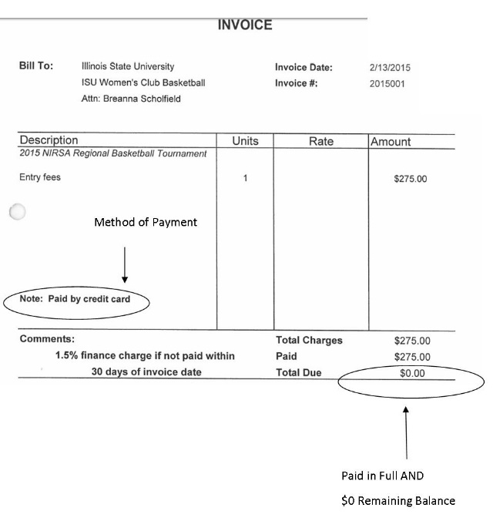
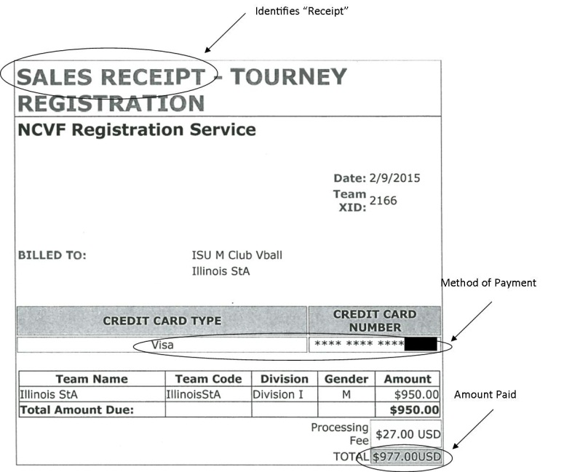
Example Receipts/Cleared Check:
Failure to secure a receipt with this information may result in the need to submit a bank or credit card statement linking the name of payee to the Credit/Debit card used and to the actual purchase. A club may also submit a copy of the processed check as proof of purchase. Sport Club Administration can advise on a case by case basis and the club should reach out as soon as possible with questions, ideally before a payment is made.
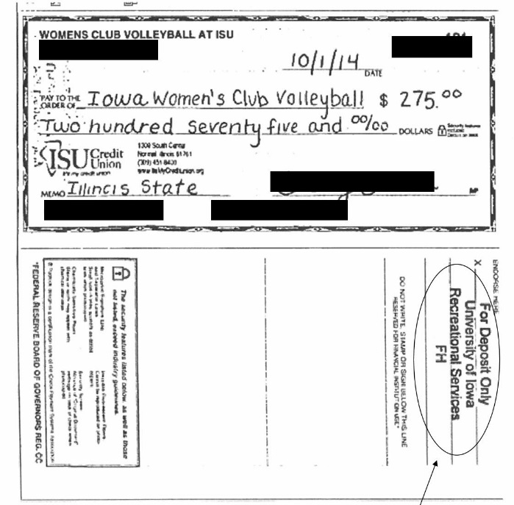

Fiscal Management by Clubs
One of the biggest responsibilities for clubs each year is self-generation of funds and management of those dollars. Clubs are required to self-generate their own funds to support their organization’s functions and are encouraged to establish membership dues (as determined by their constitutions). In generating funds, clubs should ensure their event or activity is not in violation of any laws or University procedures by reaching out to Sport Club Administration with any fundraising ideas before moving forward.

The Sport Club Executive Board has developed some recommendations for club leaders when handling finances:
- Define duties related to club expenditures and revenue
  - Who expends and approves club expenditures (President, Treasurer)?
  - Who maintains bank records, including deposits and activity reconciliations (Online banking, statements)?
- Keep track of supporting documentation (receipts and invoices, email confirmations, charges, and reimbursements)
- Establishing SMART Goals to guide your club’s financial decisions:
  - Specific – What do I want to accomplish? Who is involved?
  - Measurable – How many? How will I know when it is accomplished?
  - Attainable – How can the goal be accomplished?
  - Relevant – Does this match our vision and mission? Does this seem worthwhile?
  - Timely – When?

SAFETY
The safety of, and care for, club participants and spectators should be a top priority for clubs. It is vital for each Sport Club to identify, evaluate, and treat the potential risks in order to streamline response and mitigate risks. Risks are not limited to injury, but also include incidents that relate to club finances, image, etc. Please see our program Safety Manual for detailed descriptions and procedures. Listed below are some elements involved in the management of risk:

Elements of Risk Management
- Identification – Prior to hosting an event, traveling to a competition, or competing in any other activity clubs should identify the risks associated with that activity.
- Evaluation – Once you have identified the risks associated with the club’s activities, these risks should be evaluated to determine their severity and probability. A proper evaluation of these risks will assist the club in determining the best way to handle each risk.
- Treatment – Once the risks have been evaluated, clubs must determine the most effective method for managing each risk. Clubs may choose to do one of three things after evaluation: eliminate, limit, or accept the risks. All sport clubs, by their nature, involve risks; therefore, the answer should not always be to eliminate the activity simply because the risk exists. Instead, clubs should work to determine how to best manage and minimize the risks.
- Implementation – Once the most effective method for managing the risk has been identified clubs should implement the risk management plan. This could include physical modifications, proper signage, extensive advertising, pre-event planning, etc. The Implementation possibilities are endless and should be discussed with Sport Club Administration.

An example of having a safety plan for practice could include the following precautions:
- One safety officer should be present at all practices with the Campus Recreation Emergency Contact List, club emergency contact information, blank injury reports , and should know the location of the nearest AED and first aid kit
- If a cardiac emergency and/or other life threatening injury happens while practicing, a safety officer will call 911 (or find a Competitive Sports Supervisor, if on-campus). The first responding safety officer trained in CPR/First Aid will begin life-saving techniques within their scope of training until advanced help arrives. An officer will call and notify Sport Club Administration immediately after the emergency situation is under control.
- Club members are encouraged to bring their own water/sports drink. Coaches and officers will encourage members to rest or hydrate if they begin to feel exhausted or dehydrated
- All club members should execute pre-practice warm up activities (like stretching) to prevent potential injuries.
  - Common injuries include ankle sprains and muscle strains. The club suggests all participants wear athletic shoes to prevent ankle sprains. Warm-ups will reduce muscle strains.
- Playing surfaces will be checked for debris, wet spots and any other hazards. If the surface is unsafe, the area must be cleaned or be brought to the attention of the facilities contact. Practice will not resume until the issue is resolved.

Inclement and Severe Weather
To ensure safety and maintain field conditions, events may be cancelled due to weather or weather-related risks, such as standing water or impending/current inclement weather. For weekly practices, the decision to close the fields will be made prior to the start of the first scheduled practice (goal of 2:00pm) or onsite by the Competitive Sports Supervisor. The general guideline for assessing the field is – if there is any question or doubt about the viability of the fields, the event should be rescheduled. On-campus event cancellations will be made with consideration of teams traveling to our location.

Safety Officers
Clubs are required to maintain two (2) safety officers through the entire academic year. The club can choose to certify additional members, if they wish. The club is responsible for covering the cost of the certifications ($27.00, but subject to change). Sport Club Administration will share payment details with officers. Safety Officers must be certified in basic CPR/AED/First Aid and must complete Safety Officer Classroom Training. Sport Club Administration provides a cluster of these trainings at the beginning of each fall and spring semester. If a member wants to be a safety officer but fails to attend one of these American Red Cross Certification Courses, it is their responsibility to obtain the certification on their own. Each club is required to have at least one safety officer present at all practices, games, and travel events.

If a member has a first aid/CPR/AED certificate that was not obtained through Campus Recreation, they must submit said certification to Sport Club Administration for approval. If approved, they would only need to complete the Classroom Training to become a safety officer.

First Aid Kits
Sport Club Administration will provide the club’s safety officers a first aid kit at the beginning of each fall semester, if they’d like. If the club chooses to take ownership of this kit, they will keep it for the remainder of the academic year and return it by the last day of classes each spring, or the club’s last day of practice (whichever comes first). It is the club’s responsibility to contact sportclubs@ilstu.edu to schedule a time to restock their kit. If the club’s safety officer shows up unannounced, there is no guarantee they will be able to restock at that time.

Supplies provided in these first aid kits is for the treatment of injuries only. If your club uses athletic tape and pre-wrap for preventative measures, these supplies need to be purchased by the club. Injury reports are used to track the use of first aid supplies. A club is more than welcome to add their own supplies to the kit as needed.

Campus Recreation will also have first aid kits in the following locations:
- Horton Field House
- Horton Pool
- Gregory Street Fields
- Student Fitness Center and McCormick Hall
Below are the nearest AED’s for sport club practice locations:
- Gregory Street Field: Portable – look for Competitive Sports Supervisor
- Horton Field House: Staff Central (outside North Gym) and West Entrance (near Elevator)
- Horton North Gym: Staff Central (outside North Gym) and Field House West Entrance (near Elevator)
- Student Fitness Center Sport Courts: Court B South
- McCormick Gymnasium: Outside SFCM 254 (Athletic Training Lab)
- Off-Campus: Check with Facility

Accidents & Incidents
In the event there is an injury or incident during any Sport Club activity it must be documented for the club, the participant, and the University’s protection. The accident/incident should then be reported to the Sport Club Administration via the Accident or Incident Reports. These forms must be turned in to the Sport Club office within 48 hours. If an injury occurs that requires transportation to a hospital or if a life-threatening emergency, immediately inform Sport Club Administration via text/call and keep them updated with changes as they occur. All contact numbers will be provided to Safety Officers at training can be found in the safety officer’s first aid kit.

An Accident Report should be completed when:
- Care is provided and/or first aid supplies are used
- Someone is injured/ill/sick and is transported to the hospital/urgent care via personal vehicle or ambulance
- When someone sustains a head injury
  - The student team member/safety officer should also reference the Head Injury Tip Sheet in their first aid kit, on the website, or on Teams
An Incident Report should be completed when an atypical situation occurs. For example:
- Physical altercation
- Removing someone from the facility
- Damage to property and/or report of stolen property
- Vehicle accident
- Risk management concern and/or facility deficiency

Writing an Accident or Incident Report
When necessary to write a report, gather all possible facts concerning the incident or injury. Avoid accusations and search out facts objectively. If your club is practicing on campus, Competitive Sports Student Team Members will complete the Accident Report. If your club is off-campus or traveling, it’s the club’s responsibility to complete the form.

- The report form should be filled in with black ink as completely and accurately as possible. The report must be turned in to the Admin Suite of Campus Recreation (SFC) within 48 hours of the injury.
- Please make sure handwriting is legible.
- Try to accurately determine the time, date, and location where the incident/accident occurred.
- Keep in mind that the incident/accident report is an official document! Stick to the facts of the situation. When in doubt, state the facts only and do not diagnose injuries or state personal opinions.
- Fill out the entire report and include the phone numbers of all the parties involved and/or any witnesses to the incident/accident.
- Each report MUST include at least one witness (not the injured person, staff member, or the person completing the report).
- Obtain a case number for situations where the police or EMS are called.
- Reports should give the reader a clear idea of what occurred and care provided
- At the bottom of the accident report, print, sign, and date

Calling EMS
You should call 911 immediately in the following situations:
- The victim is unconscious, not breathing, or shows no signs of life
- You suspect a head, neck, or back injury or victim displays/reports one or more of the signs/symptoms of a concussion
- A victim is having trouble breathing or shows signs of a heart attack
- Unusual or severe bleeding
- Seizures lasting more than 5 minutes
- A victim is near drowning
- Severe burns or the victim is in shock
- Heat and cold emergencies
- If in doubt, CALL 911

After EMS has been called, call/text Sport Club Administration after care has been provided and situation stabilized. If you fail to reach the first individual attempted, call down the list until you are able to speak with a member of our administrative team. Other situations that require notifying your Sport Club Admin contact include:
- A sport club athlete leaves a club practice or event (home or away) in an ambulance or goes to a hospital without the assistance of emergency personnel
- Vehicle accident while being transported to a club practice or event (home or away)
- On-campus field or court conditions cause injury (including non-life threatening)
- Major incident requiring a call to Campus Police including fight, patron escorted from venue, weapon on site, alcohol/drug use
- Incident requiring evacuation of the building (including fire, power outage, fire alarm pulled)

In addition, please note the following action steps that need to be taken:
- The safety officer, a teammate, coach, or friend/family member should accompany the injured person to the medical facility
- The safety officer or club president will notify the club’s Sport Club Administrative Contact of the situation and keep them updated as the situation evolves

Head Injury
As participants in sports, it’s possible for concussions to occur. Campus Recreation has a head injury protocol in place for student team members and safety officers. This includes additional training for the safety officers on how to identify and respond to head injuries and the addition of an educational handout that will be in all safety officer kits and on-site for on-campus clubs. Student Team Members overseeing club practices and events are trained to call 911 if any two of the below symptoms are reported/displayed.

Headache | Confusion | Difficulty remembering or paying attention | Balance problems or dizziness
Feeling sluggish, hazy, foggy, or groggy | Feeling irritable, emotional, or ‘down’ | Nausea or vomiting | Bothered by light or noise
Double or blurry vision | Slowed reaction time | Sleep problems | Loss of consciousness

Athletic Trainer/EMT Presence (high impact sports)
Clubs are expected to send their on-campus event schedule to Sport Club Administration as soon as they know it. Sport Club Administration will try to book Redbird EMTs for the events at no cost to the club. If a high-risk club moves off campus for an event, they should work with Sport Club Administration to ensure that they have the proper safety coverage for their event, but the cost of that coverage will be the responsibly of that club.

SMART Clinic
The Sports Medicine and Rehabilitation Therapy (SMART) Clinic provides advanced care for students in the areas of prevention, evaluation, and rehabilitation. The clinic only sees students on an appointment basis. If sport club members would like to be evaluated, they will need to make an appointment with Student Health to obtain a referral. Student Health will then assist with scheduling at the SMART Clinic for initial appointment. Each one hour appointment at the SMART Clinic is $15 per visit. Serious or ongoing issues may need to be referred to a physician or specialist. Please see the above link for detailed information about hours and services, as they are subject to change.

Club Activity Definitions
The following are descriptions and considerations officers should reference when planning different club activities. If there is an activity that is not included below, officers should direct questions to Sport Club Administration before proceeding with the activity in question. Failure to adhere to the below rules as well as all local, state, and national laws could result in discipline as detailed in the Sport Club Compliance Program. The below information is provided assuming the activity is occurring in the fall-spring academic year. For considerations involving summer participation, please see the contact Sport Club Administration.

Sport Club Event
- Any activity where club members are representing Illinois State University and their sport club, such as a practice, scrimmage, competition, or club travel (for any club activity outside of the Bloomington-Normal area) that members of the club organize and participate in
  - Example:
    - Any competition
    - Travel as a club to participate in a fundraiser
    - League mandated scheduling meeting
- Sport Club Administration must be notified of all ‘Sport Club Events’ at least two weeks in advance through the submission of an Event Registration Form (this applies to any competition, travel, or scrimmage)
- The club, as an organization, must meet all eligibility requirements, detailed in this Sport Club Handbook, in order to be considered active and have their event recognized
- Only current club members that have met all the Sport Club requirements for that sport may participate in a ‘Sport Club Event’. Requirements include:
  - Currently enrolled, fee-paying student of Illinois State University
  - Has completed a Sport Club Participant Waiver for the current school year
- All Sport Club Events should be recorded on the club’s monthly participation in Redbird Life
- If an on-campus event meets the below criteria, the club will be required to purchase event insurance before the event can take place:
  - Any event that has three (3) or more visiting teams, regardless of where those teams are from
    - Example: Women’s Lacrosse is hosting Northern Illinois, Bradley, and Southern Illinois – needs insurance
  - Any event with two (2) or more teams where at least one team is from outside the state of Illinois State University
    - Example: Women’s Lacrosse round robin with Indiana and Bradley – needs insurance
  - Any single game event will not need insurance, regardless of where the team is from
    - Example: Men’s Rugby plays Marquette – does not need insurance

Sport Club Recruiting/Tryouts
- Any activity held by a Sport Club that is used to determine its members for the upcoming season, academic semester, or year
- Sport Club Administration must be notified of all ‘Sport Club Tryouts’ at least two weeks in advance
  - Depending on the nature and location of the activity, Sport Club Administration may require additional information or paperwork, such as an Event Registration Form for Facility Request before the activity is approved.
- Current Illinois State students may participate in a tryout as long as they have signed a Sport Club Participant Waiver
  - This wavier would not be valid for non-ISU students (including students who intend to attend ISU in a coming semester) and clubs are strongly encouraged to create a separate waiver to protect their organization
- Non-Illinois State students may participate in a tryout as long as they will be eligible to participate with the club in the upcoming academic semester of year
  - For activities that include non-ISU students, University procedure may dictate what facility space the activity can be held in
- All recruiting/tryouts should be recorded on the club’s monthly participation, however, only current ISU students will have a valid ID listed.

Sport Club Meeting
- Any Sport Club meeting held in the Bloomington-Normal area that does not include participating in the sport or related physical activities, but rather is related to the mission and/or goals of the club, such as informational meetings, watching film, or discussing club business
  - Sport Club Administration does not need advanced notification of meetings, unless the club is reserving space on campus
  - Both club members and non-club members may be present at a ‘Sport Club Meeting’
- If the club is holding a meeting outside of the Bloomington-Normal area, please see the aforementioned ‘Sport Club Events’ section as travel is involved
- All Sport Club Meetings should be recorded on the club’s monthly participation report

Sport Club Philanthropy
- Any activity organized by the club designed to support the club and/or community that does not directly benefit the club
  - Sport Club Philanthropy events, off-campus, in the Bloomington-Normal area do not require advanced notice to Sport Club Administration, but should be recorded in the monthly participation like on-campus events
  - After all community service events, regardless of location, clubs should submit an Involvement Report summarizing their event
- If a club seeks to hold a ‘Sport Club Philanthropy’ event on campus, Sport Club Administration needs to be made aware via email at least two weeks in advance to ensure all University procedures are being followed
- If the club is traveling for the philanthropy event, please see the aforementioned ‘Sport Club Events’ section as travel is involved

Sport Club Alumni Event
- Any event planned by current or past club members with the goal of bringing together current club members and alumni members of the club
- If a club is considering planning an alumni event, Sport Club Administration should be contacted as there are various resources available to help the club with the process.
- If current club members are planning the event, an Event Registration Form is required at least two weeks in advance listing all ISU students participating along with event details, such as location and time.

Home and Away Event Registration
Each semester, every Sport Club must submit their Event Schedule by the date listed on the Event Calendar to Sport Club Administration. The Club Event Schedule should include all home and away competitions (scrimmages, tournaments, league games, etc.) for the entire semester, including possible post-season competition and alumni events. If any changes are made to the schedule, the team representative must notify their Sport Club Administration Contact.

Once the club’s Event Schedule has been submitted, the club must complete an Event Registration Form at least two weeks prior to each home and away competition. Notifying the Sport Club Program of each trip or home event must occur at least two weeks prior to the event. The form includes a comprehensive roster (complete list of all students traveling, emergency contact numbers for those traveling, ULIDS), the method of transportation used for travel, dates and locations of overnight accommodations, and the competition location.

For home (on-campus events) there are specific guidelines that must be followed depending on the facility your club is using for said event. Please contact Sport Club Administration as soon as you know you plan on hosting an on-campus event so they can make you aware of these guidelines and provide support. For example, one of these guidelines is all visiting participants must sign a Visitor Waiver before participating in a club event.

NOTE: A club’s event may not be recognized if they fail to submit the Event Registration Form and Roster at least two weeks prior to the event. Any expenses associated with the cancellation of the event will be the club’s responsibility. The club must adhere to all Illinois State University and Division of Student Affairs procedures and conform to all travel guidelines stipulated by the Department of Campus Recreation.

Travel Rules
The Department of Campus Recreation, in accordance with Risk Management and Legal, places certain stipulations on Sport Club travel in order to encourage and promote responsible safe travel:
- Any trip must have a certified safety officer present
- Club vehicles, both personal and fleet, may not travel between midnight – 5:00am (exception: Charter Buses with driver(s) provided)
- Drivers should not drive for more than four hours consecutively without at least a two hour break
- No driver should log more than eight hours each calendar day
- Participants should not consume or transport alcoholic beverages or drugs from the time the club departs Normal for their trip through the time they return.

Post Event Report
After returning to Illinois State University after a club event, clubs must complete and submit the Post-Event Report online form by the Monday at 2:00pm following the event. In addition to providing a review of the competition and a picture from the trip, it will allow Campus Recreation to promote club successes through press releases, social media, the department website, and other various formats.

Class Absence Letters for Sport Club Events
Student participation in Sport Clubs is a privilege, not a right. Sport Club events and activities are not identified as sanctioned University activities according to Illinois State University Policy 2.1.20. However, most instructors are willing to accommodate Sport Club student-athletes if you communicate responsibly and are proactive about missed classes. That means students are responsible for 1) informing instructors of scheduled absences in advance (we recommend identifying all possible absences at the beginning of the semester or as soon as they come available; include any conference, regional and national events) and 2) arranging to complete missed classroom work. The class absence letter is only a notification of travel.

CLUB OBLIGATIONS
- Clubs must submit their semester competition EVENT SCHEDULE (includes home and away events) per the deadlines listed on the Sport Club Calendar by emailing list of event details to Sport Club Administration.
- At least two weeks prior to departure date of event, clubs must submit an Event Registration Form where they can indicate if they need a class absence letter for said trip.
  - If the class letter is needed sooner, Event Registration must be submitted earlier.
  - ALL anticipated attendees should be listed on the Event Roster. It’s not guaranteed that a new letter will be created if the roster changes after submission

PROGRAM COURTESIES
- The Sport Club Program will compile a list of all home and away competitions, in addition to any extracurricular events (fundraisers, family/alumni events, etc.).
- Clubs are emailed two weeks in advance and notified of Event Registration Form deadline, if they have registered their event by sending their event schedule.
- Once approved, an official letter is created (if requested on the Event Registration) confirming the reason and days/times the student will be absent to provide for their professors. An official copy on University letterhead will be emailed to the individual who completed the Event Registration Form and it is their responsibility to then distribute it to members who need it.

RESTRICTIONS
- Class absence letters are not available post event or less than two weeks prior to the event.
- The roster must be completed before receipt of letter (all members on roster have submitted waiver).
- Any updates need to be provided more than one week prior to departure for the event. This includes people who join the roster late and request a letter. There is no guarantee changes will be made to a letter after the two-week deadline.

Personal Vehicles
If and when a club chooses to travel using personal vehicles, it is recommended that the club’s travel coordinator/safety officer verify that each person driving has insurance coverage suitable for group travel and a valid driver’s license. It is also recommended that each personal vehicle undergo a safety inspection prior to departure.

At minimum, a safety check should include checking headlights (high & low beams), tail & brake lights, horn, windshield wipers, parking break, mirrors, tire tread & inflation, brake system, engine oil, fluid levels, defroster check, turn signals/hazards, and seatbelt. The vehicle being used for travel should have regular checks for other mechanical functions.

If a personal vehicle does not pass the basic check listed above, it is strongly recommended that the vehicle NOT be used for club travel. ISU, Campus Recreation, and the Sport Club Program are NOT responsible for vehicle damage while on a trip or event.

Personal Vehicle Accidents
In case of an accident that occurs with either a personal or University vehicle, please adhere to the following established by Illinois State’s Facilities-Fleet and listed on their website, with additional items developed by Campus Recreation:
- Contact area emergency personnel via 911. Make sure that all individuals receive medical attention immediately.
- Obtain the names and addresses of all witnesses, licenses of other drivers, and people involved in the accident.
- Obtain the names of the insurance companies of all vehicles involved in the accident.
- Contact Sport Club Administration. If unavailable, leave a message and notify the Assistant Director.

RESERVING ISU FLEET VEHICLES FOR CLUB TRAVEL
Vehicles reservations can be made at any time but the number of vehicles available is limited. They are reserved on a first-come, first-served basis and must be reserved at least TWO weeks prior to date of departure. Event Registration Forms are also due at least TWO weeks prior to date of departure. Please see our website for instructions on reserving Fleet vehicles.

University Fleet Vehicle Accidents
Clubs should adhere to the above rules in addition to those outlined below. University owned vehicles operated by an employee or other authorized individuals (used for approved purposes; see University Policy 5.4.2) are covered by the State of Illinois Self-Insured Motor Vehicle Liability Plan. If a club is involved in an accident involving a University vehicle, they should contact Sport Club Administration for help with the following steps after contacting police.

Reporting procedures involve the following:
- Completion of SR-1 form, "Motorist's Report of Illinois Motor Vehicle Accident"
  - This form is usually found in the glove box of each vehicle. If not available, a copy can be found on the ISU Risk Management website under Forms
  - NOTE: If you are not able to submit the completed SR-1 promptly, please contact Risk Management at 309-438-2145 or 309-438-1900 with the required information.
- Facilities must be notified immediately, by calling the Fleet Dispatcher (309.438.2038) during business hours or Illinois State University Police Department (309.438.8631) after 7:30am-5:00pm Monday-Friday.
- Failure to promptly report accidents can result in significant liability to the university and may also result in club disciplinary action.
- Prompt submission of completed SR-1 form to University Risk Management.
Please e-mail to RiskManagement@IllinoisState.edu or mail to: ISU Risk Management, Campus Box 1100, Normal IL 61790-1100
- Availability by phone or email for any required follow-up matters

Please pay special attention to:
- Recording Owner of Vehicle
- State owned - If Illinois State University is the owner of the vehicle, under “Insurance” please enter "State of Illinois Self-Insured Motor Vehicle Liability Plan".
- Privately owned or leased - Complete all driver and owner information and under "Insurance" list information on your personal carrier.

For Fleet accidents, inform the third party to contact:
Department of Central Management Services
Risk Management Division - Auto Liability Section
201 East Madison Street
3rd Floor, North Wing
Springfield, IL 62706
Phone: (217-782-0202) or (800-442-1300, ext. 4)

In addition to the completed SR-1 form, provide the following information in a report to Risk Management:
- Social security number
- Work title of employee (if applicable)
- Daytime phone number for employee/student
- Police report copy if available
- Brief written statement of how accident occurred
- Incident report for Sport Club Administration
- Traffic controls present
- Weather conditions
- Any traffic citations issued
- Other extenuating circumstances

The above information should be made available to anyone who might be driving a vehicle on University business. All automobile accidents involving a university employee or other authorized person operating a university vehicle must be promptly reported to the proper authorities and then Sport Club Administration. This includes minor accidents in which you may believe there is no damage or injury. Failure to promptly report accidents can create significant liability to the University and may result in disciplinary action.

FACILITY REQUESTS
Throughout the academic year, Competitive Sports within Campus Recreation has three facilities available for use by both the Intramural Sports and Sport Clubs programs, Horton (North Gym, Field House, South Gym, and Pool), Gregory Street Fields & Tennis Courts, and McCormick Gym. The availability for these locations is subject to change and the Sport Club program does not take priority

If a Sport Club wishes to reserve a facility for practice or an event, they must abide by the following procedures and guidelines:
- Club must completely fill out the Facility Request Form and submit to Sport Club Administration. You can download this form on the Campus Recreation website (must have your advisor’s wet signature in order to process).
- Spaces are reserved in the order these completed requests are received.
- This form must be submitted to the Sport Club Administration via delivery to the Campus Recreation Main Office or via email with a PDF of the document complete with wet signatures.
- Facility Requests and Use Agreements should be submitted by the assigned deadlines to verify availability and provide the necessary time to coordinate the event.
- Campus Recreation will provide a sprayer, paint, and lining equipment for the club to re-line their field during their competitive season. This must happen when a supervisor is present and after clubs have scheduled the paint session with Sport Club Administration.

Practice Sessions
Each club will have ability to request the above spaces for practices, but times and/or days available will vary. Clubs will work with Sport Club Administration each semester to identify their practice days/times based on facility availability and staffing coverage. If a club requests a day/time outside of normal request (for example, a club wants to add an additional practice day), the club may be responsible for covering the cost of staffing for the request.

General Rules
- All users must have a valid Illinois State University ID card or be listed on the event list.
- Campus Recreation reserves the right to implement any guidelines that protect the health and safety of the facility and its users.
- Fields will be evacuated and closed in the event of inclement weather, flooding, or any other potentially hazardous situations as determined by Campus Recreation Student Team Members on duty.
- Space cannot be guaranteed and all reservations are subject to change. The earlier the request is made, the better we are able to accommodate your club.
- Clubs should reference the Facility Request for a list of equipment available for use at their event.
- If procedures are not followed prior to or during the event, the club may not be allowed further facility use, and may have other consequences.
- ISU Campus Recreation has the right to restrict access or contact ISU Police if University and Department procedures are not being followed.
- Spectators and coaches are welcome to attend club activities, but must follow all Campus Recreation and facility guidelines for gaining access. The hosting Sport Club is responsible for damage by all spectators and opponents.
- If facilities and/or equipment are damaged during Sport Club activities, it is the responsibility of the club to report such an occurrence to Sport Club Administration. The cost of repair/replacement is the responsibility of the club and the individual member(s) responsible.
- Campus Recreation works with many partners and club practices may be moved or altered to accommodate third-party reservations.
- If a club reserves a facility and does not intend to use the site, Sport Club Administration MUST be notified of the cancellation by at least 2:00pm the day of the practice. If the cancellation is for an event, at least 24 hours in advance is preferred. If a cancellation is not made, the club may be charged that standard rental rate for the facility and for the hourly time required to set-up the facility.
- Campus Recreation is not responsible for lost, stolen or damaged items.
- Trash and recycling must be placed in appropriate containers.
- No animals are permitted in facilities except for service animals. At Gregory Street Fields, the dogs can be present but should be leashed. If at any point, they interfere with play or pose a risk to spectators, the owner will be instructed to go to the tree line with dog.
- No alcohol or cannabis/tobacco products are permitted in facilities, including outside at Gregory Street Fields, or parking lots.
- All cars, trucks, motorcycles, and mopeds must park in designated spaces and are prohibited on the fields.

MISCELLANEOUS

Redbird Life
Redbird Life is the University sponsored way to market your club to other students and maintain active RSO status (required to be a sport club). All clubs are required to maintain their individual page, including updating their roster, pictures, and social media. The roster should list all active members each semester and the most recent version of the constitution should be accessible to the public. Officers should monitor the page regularly to ensure interested individuals receive the information about the club they might be seeking.

Clubs are required to track the participation of their club members through submission of monthly participation counts in the Redbird Life system. Involvement in club activities should be tracked for all meetings, try-outs, practices, scrimmages, tournaments, games, fundraisers, and recruitment efforts. Participation is due by the 5th of each month for the previous month. For example, October’s participation is due on November 5th. Counts for partial months may be due earlier (December and May).

Sport Club Leadership Series
The Sport Club Leadership Series was created to provide training and leadership development opportunities to the officers and members of sport clubs. The goal for these offerings is to provide officers with leadership skills that they can use to manage their club, succeed in classes, find a job after graduation, and become more well-rounded individuals. Topics range from community involvement and budgeting to conflict management and recruitment.

Team Building Activities
Team building programs can be booked at any time, but further out is better. Programs are available for low ropes and high ropes courses, portable programs, the climbing wall, and rappel tower. As a RSO and Sport Club, grants are available to help you pay for your program.

“Clubs That Care” Community Involvement
The Sport Club Program is committed to giving back to the local and University communities. The program developed a month-long initiative promoting community service and philanthropy that includes, but is not limited to, and Club that Care Blood Drive, partnering with the Red Cross and partnering with The Center for Civic Engagement g to get clubs involved with Bring it Back to Normal. Although the Sport Club program provides coordination of these events, individual clubs are encouraged to initiate their own service and philanthropic efforts. Assistance with a local agency or cause, or promotion of an event or defining proceeds to a charitable organization are all options available to Sport Club teams to give back.

Involvement Form
Participation in community engagement efforts both on and off campus is strongly encouraged. Club involvement in the community results in benefits for both the club members and the population they are assisting. It provides an opportunity for club members to give back to their University and local communities, develop strong public relations efforts in the area, build relationships with stakeholders and potential donors, and contribute to developing civically engaged citizens.

Sport Club Leadership Awards
At the conclusion of the academic year, the Sport Club Executive Board hosts the Sport Club Leadership Awards, which includes food, drink, and leadership awards. Clubs are encouraged to nominate their club and participants for the available awards highlighting the values the Sport Club program promotes throughout the year. More information will become available on this event during the spring semester.

Info Meetings
An Info Meeting is a time for your club to provide specific details about your organization to interested members. It usually takes the form of a presentation covering travel schedule, dues, and club expectations. It’s a good way to get people information before they show up to the first practice. These typically happen the first two weeks of classes in the fall and spring. If your club would like classroom space for these meetings, please reach out to Sport Club Administration directly to schedule. Given the limited space available, we recommend that clubs consider holding these meetings virtually this year for the convenience of all involved.

Apparel and Branding
Club teams are permitted to utilize university names as well as the Reggie Redbird head and full-body logos. However, the proportions, spacing, and size have been carefully established and must be followed. Use original logo files without alteration. A club is allowed to create a unique logo, but it must be approved before production.

**All club apparel, jerseys, and merchandise must have the word ‘club’ as part of the design. Failure to do so may result in sanction or fine.**

As all designs for team apparel and promotional pieces much be approved by University Marketing and Communications prior to production, please send image proofs/examples to Sport Club Administration. Sport Club Administration will forward onto Trademark and relay changes that need to be made. This allows Sport Club Administration to catch initial issues and keep track of club logos in use. If in doubt about a design, send it to Sport Club Administration!

The Redbird head and full-body logos may be used independently or in association with club names on promotional products as long as the vendor is licensed to print. These logos may NOT be altered in any way. This includes any clothing, adorning with objects, and over-obstructing with type or objects. Files can be pulled directly from this website: https://universitymarketing.illinoisstate.edu/identity/logos/.

Note about Vendors:

All vendors (the company producing your items) must be licensed to use the University’s logos. You can check if your vendor is licensed by going to this site: https://universitymarketing.illinoisstate.edu/identity/licensing/.

If you don’t see your vendor listed, they can become a licensed vendor. Instructions are on the site – send them the link above.

Trademark recommends you choose an internal company that is listed and licensed – 4imprint was recommended by them.

If they are a sport specific company, for example they only make lacrosse helmets, they aren’t likely to be licensed. Send me an email and we’ll work case by case. If in doubt, send me the company name for verification (this should only be done once you have checked the website).

Once they become licensed, they will receive instructions from the Trademark Office for how to access the vendor portal.

I’d strongly recommend checking if the company you want to use is licensed/willing to get licensed before you get too deep into planning.

When university trademarks are used on products (apparel, etc.), please refer to the below. These are examples and are not all encompassing:

® | Illinois State University and Illinois State
® | Redbird and Redbirds
® | Redbird head and Redbird full-body logos
™ | ISU
Not permitted | University seal
Not permitted | ‘State’ or ‘I State’
Not permitted | Most of the ‘retro’ logos
Not permitted | ‘ILSTU’
Not permitted | ‘Birds’ or ‘Bird’

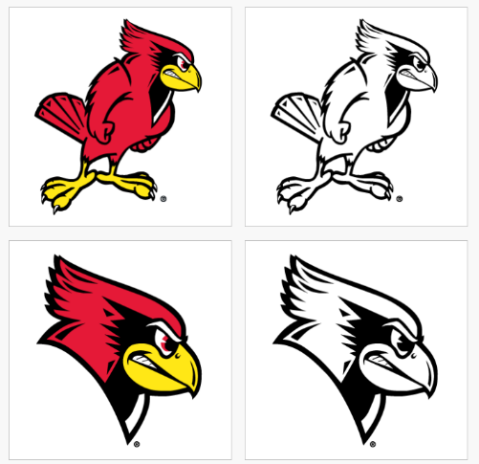

Approved for use by clubs:

Redbird Athletics logos may NOT BE used in association with any club team. Examples include:

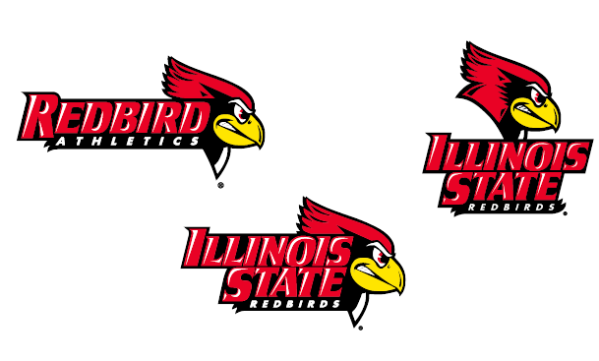

Recruitment Opportunities
- Sport Club Expo is a program sponsored event the first week of classes that is designed for clubs to recruit new members. Attendance is required for at least one officer from every club.
- Festival ISU is the traditional fall welcome to campus event. Registered Student Organizations and local businesses are present on the quad with information about their groups.
- Winter Fest is the recruitment fair in the Bone Student Center at the beginning of the spring semester. Registered Student Organizations are present with information about their groups.
- Tabling (SFC, Quad, and BSC) opportunities are available throughout the academic year in various venues on campus. Clubs must reserve the tables through the appropriate entity.
  - Bone Student Center and Quad (South of Milner Bridge) – Contact the Non-Academic Scheduling Office at 309-438-2403
  - Student Fitness Center – Work through Sport Club Administration to reserve
- Campus Advertising Guidelines
- Campus Recreation Website

Club Social Media
All clubs are encouraged to operate social media accounts on behalf of their clubs and also follow and engage with the Campus Recreation accounts. Clubs should strive to represent the University and program in a positive light.

If your club would like an event, such as a home game, featured on Campus Recreation’s social media platforms, THIS FORM must be submitted at least two weeks in advance. Approval is not guaranteed, but it’s highly preferred that clubs submit as soon as event details exist. Questions about this can be directed to Sport Club Administration.

